**PROJECT REPORT ON**

***DISH IS WISH***

***(Online Information Search)***

**FOR**

***VEDANT IT ACADEMY***

**BY**

**JAGRUTI DIGAMBAR PATIL**

**SHWETA BABURAO DESAI**

**SHEETAL SHATARAM TIWARI**

**MASTER OF COMPUTER**

**APPLICATIONS**

**SEMESTER VI**

IBSAR Institute of Management Studies, Karjat

**UNIVERSITY OF MUMBAI**

***Year-2013-2014***

**Internship Completion Certificate**

TO WHOMSOEVER IT MAY CONCERN

This is to certify that **Miss. Patil Jagruti D, Miss. Desai Shweta B, and Miss. Tiwari Shital S students** of MCA Course from **IBSAR Institute Of Management and studies** has successfully completed his sixth semester Project training at **Vedant IT Academy.**

**Name of the Project : Dish Is Wish system**

**Duration : 15th January 2014 to 15thJune 2014**

**Front End : PHP**

**Back End : MYSQL**

Their project is found to be useful in the relevant business and they have submitted a copy of the project report to us. During their project period we find them sincere, hard working and having good behavior and moral character. We wish them all success in their future endeavor.

**C E R T I F I C A T E**

This is to certify that **Miss.Patil Jagruti D, Miss.Desai Shweta B, Miss.Tiwari Shital S**  has completed Project on“**Dish Is Wish System”** for the requirement of 3rd year (VI Sem) of Master of Computer Application of University of Mumbai during the year 2013-14.

______________ ___________

Internal Guide Coordinator MCA

College Seal

______________ ________________

External Examiner Principal

Date: ____________

**Acknowledgement**

Any accomplishment requires the endeavor of many people, and we are indebted to many individuals who contributed to the development of this project work. It is with a great pleasure that we present our first venture in real life application of computing in the form of project work.

We are indebted & thankful to our Project guide and to whom we owe this piece of knowledge his valuable guidance, cooperation and encouragement and time spent for this project work.First of all we extend our sincere thanks to the faculty members of M.C.A department who tuned our knowledge in fieldof I.T. We sincerely thank them for their unconditional support and also for their co-operation and guidance throughout the course of this project with respect to every aspect of the project.

We extend our sincere thanks to H.O.D of M.C.A (DEPT) Prof. . We are also thankful to Prof. Mrs. Yojana Ambavkar who showed faith in me and guided me throughout the course of the project.

We are also grateful to my family members for constantly supporting us and we would like to thank all those who helped me directly or indirectly during my project encouraging us to put our best efforts for continued improvements of our project.

Patil Jagruti D.

Desai Shweta B.

Tiwari Shital S.

**Index**

|  |  |  |
| --- | --- | --- |
| **Sr no** | **Contents** | **Page No** |
| **1** | **Introduction**   * 1. Company Profile   2. Existing System and Need for System   3. Scope of Work   4. Operating Environment – Hardware and Software | 8  8  8 |
| **2** | **System Analysis**  **2.1 Feasibility Study**  2.1.1 Technical  2.1.2 Operational  2.1.3 Resource  (S/W development Model depends on Project Type)  **2.2 System Planning and Schedule**  2.2.1 GANTT Chart | `  35  35  36  36  40  40 |
| **3** | **System Design**  **3.1 Software Requirement Specification**  3.1.1 Introduction  3.1.2 Selection of Technology/Specific Requirements  3.1.2.1 Hardware to be used  3.1.2.2 Software to be used  3.1.2.3 Tools to be used  **3.2 Detailed Life Cycle of the Project**  3.2.1 Modules  3.2.2 Object Oriented Analysis & Design Diagrams  3.2.2.1 UML Diagrams  3.2.2.2 DataFlow Diagrams  3.2.3 Database  3.2.3.1 Database table | 42  42  45  45  46  46  48  51  51  52  52  56  67 |
|  |  |  |
| **4** | **Testing (V Model)**  **4.1 Methodologies used for testing**  **4.2 Types of testing**  4.2.1 White Box Testing  4.2.2 Black Box Testing  **4.3 Test Cases**  4.3.1 Functionality Testing  4.3.2 Usability Testing  4.3.3 Performance Testing  **4.4 Test Reports** | 74  76  76  78  80  80  80  80  81 |
| **5** | **System Implementation**  **5.1Hardware Required at client**  **5.2 Software Required at Client**  **5.3 Testing done at End User** | 85  85  85 |
| **6** | **System Maintenance & Evaluation**  **6.1 Maintenance**  **6.2 Evaluation** | 88  90 |
| **7** | **User/Operational Manual**  **7.1 Security Aspects, Access Rights**  **7.2 Back Up’s**  **7.3 Screen Shots** | 93  94  96 |
| **8** | **Future Enhancements** | 110 |
| **9** | **Limitations** | 119 |
| **10** | **Conclusion** | 121 |
| **11** | **Appendices** | 123 |
| **12** | **Bibliography** | 126 |

**1.1 Abstract**

The main aim of our project is to create a system for a users so that it can know all information about restaurants and recipies online.

The system can be used by Admin and even user to check there system. Admin can create its account required and even assign each account to the user. Only Admin has the right to assign the account. Admin can even add,update and delete records will be stored in the database and again retrieved from the database.

* + 1. **About the Organization**

Vedant IT Academy is one of the based academy which is give training on web application and website development and work on live professional IT project.

They like to solve problems, accept new challenges and provide a satisfactory solution to end users.

They interact with end users continuously in all the phases of design, development, testing and production. They also maintain, release system in client environment.

**1.1.2 Services Provided**

Vedant IT Academy has in-depth experience in developing web application and website design strives to provide the custom solutions to the clients that will help him to remain in step with the competition by continuously improving their information technology based business solutions. For this, the company use modern software development platforms, software development tools as well as employ latest project management techniques and software. The company has gained vital process knowledge and has

distinctive library of software codes. Company also provides other services such as, desktop application.

* + 1. **About the Project**

Dish Is Wish is provide an online platform which gives list for all hotels and recipies in all the regions online. Nowadays, internet has reached almost to everywhere. So it is necessary to utilize the available resources efficiently and for the benefits of all the users.

We should able to get all the things in one look .There will be the city wise listing of all hotels and kitchen compass with their contact numbers and address.It give Facility to add into the wish list.It Will display all brands and their products .

So that users will get all information at once anywhere so that it saves time.

* 1. **Objective & Scope of the Project**

**Objective of the Project**

To provide an online platform which gives list for all hotels and recipies in all the regions online.

It gives citywise description of all hotels and restaurants online and provide facility to add your favourate dish into wishlist.It help to the user to see their favourate dish whenever they login.No need to users search their favourate dish after they add their favourate dish into wishlist.

In kitchen compass provides all shops and malls information where found all materials which want to make recipies.

In Exhibition provides all products listed according to their brands.It helps to the users to know brand of all products and they buy that products according to the brand

The main objective of the project is to design and develop a user friendly, easy to use and an efficient web system.

Computerization can be helpful in reducing the manual workload.

Computerization can be viewed as a means of saving time and cost.

To provide better Graphical User Interface (GUI).

Perform necessary validations & minimizes errors.

It can be suitably modified & expanded in future for further needs.

**Feasibility Report**

Preliminary investigation examine project feasibility, the likelihood the system will be useful to the organization. The main objective of the feasibility study is to test the Technical, Operational and Economical feasibility for adding new modules and debugging old running system. All system is feasible if they are unlimited resources and infinite time. There are aspects in the feasibility study portion of the preliminary investigation:

* Technical Feasibility
* Operation Feasibility
* Economical Feasibility

**Technical Feasibility:**

The technical issue usually raised during the feasibility stage of the investigation includes the following:

* Does the necessary technology exist to do what is suggested?
* Do the proposed equipments have the technical capacity to hold the data required to use the new system?
* Will the proposed system provide adequate response to inquiries, regardless of the number or location of users?
* Can the system be upgraded if developed?
* Are there technical guarantees of accuracy, reliability, ease of access and data security?

Earlier no system existed to cater to the needs of ‘Secure Infrastructure Implementation System’. Thus it provides an easy access to the users. The database’s purpose is to create, establish and maintain a workflow among various entities in order to facilitate all concerned users in their various capacities or roles. Permission to the users would be granted based on the roles specified. Therefore, it provides the technical guarantee of accuracy, reliability and security. The software and hard requirements for the development of this project are not many and are already available in-house at NIC or are available as free as open source. The work for the project is done with the current equipment and existing software technology. Necessary bandwidth exists for providing a fast feedback to the users irrespective of the number of users using the system.

**Operational Feasibility:**

Proposed projects are beneficial only if they can be turned out into information system. That will meet the organization’s operating requirements. Operational feasibility aspects of the project are to be taken as an important part of the project implementation. Some of the important issues raised are to test the operational feasibility of a project includes the following: -

* Is there sufficient support for the management from the users?
* Will the system be used and work properly if it is being developed and implemented?
* Will there be any resistance from the user that will undermine the possible application benefits?

This system is targeted to be in accordance with the above-mentioned issues. Beforehand, the management issues and user requirements have been taken into consideration. So there is no question of resistance from the users that can undermine the possible application benefits.

**Economic Feasibility:**

A system can be developed technically and that will be used if installed must still be a good investment for the organization. In the economical feasibility, the development cost in creating the system is evaluated against the ultimate benefit derived from the new systems. Financial benefits must equal or exceed the costs.

The system is economically feasible. It does not require any addition hardware or software. Since the interface for this system is developed using the existing resources and technologies available at NIC, There is nominal expenditure and economical feasibility for certain.

**Scope:**

These type of system can be used in anywhere where the internet is found

* Nowadays, internet has reached almost to everywhere.
* So it is necessary to utilize the available resources efficiently and for the benefits of all the users.
* We should able to get all the things in one look .
* There will be the city wise listing of all hotels and kitchen compass with their contact numbers and address.
* Facility to add into the wish list.
* Will display all brands and their products .
* So that users will get all information at once anywhere so that it saves time.
  1. **Theoretical Background**
     1. **Overview of Front End**

PHP is very well accepted scripting language used essentially to generate sketch for most online PHP Web Development applications. A proficient Core PHP Developer would deliver skilled and vibrant website with a view of building further user-friendly and interactive. Solutions for enterprises and to produce a complete application with multi-tier design Core PHP development is the model choice. Joomla Development is one of the resources of Core PHP. In the updated life, PHP development is necessary and it is free of license. Core PHP programming is one of the most emergent programming languages all around the globe.

PHP was built with the intent of providing simplicity and choices and this is clearly relected in the number of options available in the building applications **PHP** is a [server-side scripting](http://en.wikipedia.org/wiki/Server-side_scripting) language designed for [web development](http://en.wikipedia.org/wiki/Web_development) but also used as a [general-purpose programming language](http://en.wikipedia.org/wiki/General-purpose_programming_language)

PHP is an HTML-embedded scripting language. Much of its syntax is borrowed from C, Java and Perl with a couple of unique PHP-specific features thrown in. The goal of the language is to allow web developers to write dynamically generated pages quickly.

PHP/FI 2.0 is an early and no longer supported version of PHP. PHP 3 is the successor to PHP/FI 2.0 and is a lot nicer. PHP 5 is the current generation of PHP, which uses the [» Zend engine 2](http://www.zend.com/) which, among other things, offers many additional [OOP](http://www.php.net/manual/en/language.oop5.php) features.

* PHP can generate dynamic page content
* PHP can create, open, read, write, delete, and close files on the server
* PHP can collect form data
* PHP can send and receive cookies
* PHP can add, delete, modify data in your database
* PHP can restrict users to access some pages on your website
* PHP can encrypt data.
* PHP runs on various platforms (Windows, Linux, Unix, Mac OS X, etc.)
* PHP is compatible with almost all servers used today (Apache, IIS, etc.)
* PHP supports a wide range of databases
* PHP is free. Download it from the official PHP resource: [www.php.net](http://www.php.net/)
* PHP is easy to learn and runs efficiently on the server side.

If your server has activated support for PHP you do not need to do anything.

Just create some .php files, place them in your web directory, and the server will automatically parse them for you.

You do not need to compile anything or install any extra tools.

Because PHP is free, most web hosts offer PHP support.

**Installation:**

* Access to a web server (like Apache)
* PHP and MySQL should be installed on the web server.

The easiest way is to find a cheap web hosting plan that support PHP and MySQL (most of the web-hosting providers do.) For a couple of bucks a month you can get a virtual host. The advantage is that everything is already installed and that you can share your program (that you are going to write) with the rest of the world.

If you don’t want to spend money, you can also install everything on your local machine. The easiest way is to install WAMP if you have a Windows machine and LAMP if you have a Linux machine. ([**WAMP**](http://www.wampserver.com/en/) = Windows Apache MySQL PHP and LAMP = Linux Apache MySQL PHP.) These packages install everything you need. Read the install manual of

these packages for instructions. After installation you should have access to http://localhost in your browser.

**HTML**

Unlike many object-oriented languages, there is no distinction between a function definition and a method definition. Rather, the distinction occurs during function calling; a function can be called as a method. When a function is called as a method of an object, the function's local this keyword is bound to that object for that invocation.HTML5 is a markup language for structuring and presenting content for the World Wide Web, and is a core technology of the Internet originally proposed by Opera Software. It is the fifth revision of the HTML standard (created in 1990 and standardized as HTML4 as of 1997) and, as of May 2012, is still under development. Its core aims have been to improve the language with support for the latest multimedia while keeping it easily readable by humans and consistently understood by computers and devices (web browsers, parsers, etc.).

HTML5 is intended to subsume not only HTML 4, but XHTML 1 and DOM Level 2 HTML as well. Following its immediate predecessors HTML 4.01 and XHTML 1.1, HTML5 is a response to the observation that the HTML and XHTML in common use on the World Wide Web are a mixture of features introduced by various specifications, along with those introduced by software products such as web browsers, those established by common

practice, and the many syntax errors in existing web documents. It is also an attempt to define a single markup language that can be written in either HTML or XHTML syntax.

**CSS**

Cascading Style Sheets (CSS) is a style sheet language used for describing the presentation semantics (the look and formatting) of a document written in a markup language. Its most common application is to style web pages written in HTML and XHTML, but the language can also be applied to any kind of XML document, including plain XML, SVG

and XUL.CSS is designed primarily to enable the separation of document content (written in HTML or a similar markup language) from document presentation, including elements such as the layout, colors, and fonts.

This separation can improve content accessibility, provide more flexibility and control in the specification of presentation characteristics, enable multiple pages to share formatting, and reduce complexity and repetition in the structural content (such as by allowing for tableless web design). CSS can also allow the same markup page to be presented in different styles for different rendering methods, such as on-screen, in print, by voice (when read out by a speech-based browser or screen reader) and on Braille-based, tactile devices. It can also be used to allow the web page to display differently depending on the screen size or device on which it is being viewed.

**Javascript:**

JavaScript is the programming language of the Web.

All modern HTML pages are using JavaScript.

JavaScript is easy to learn.

**Ajax:**

AJAX is about updating parts of a web page, without reloading the whole page.

AJAX = Asynchronous JavaScript and XML.

AJAX is a technique for creating fast and dynamic web pages.

AJAX allows web pages to be updated asynchronously by exchanging small amounts of data with the server behind the scenes. This means that it is possible to update parts of a web page, without reloading the whole page.

Classic web pages, (which do not use AJAX) must reload the entire page if the content should change.

Examples of applications using AJAX: Google Maps, Gmail, Youtube, and Facebook tabs.

How AJAX Works.

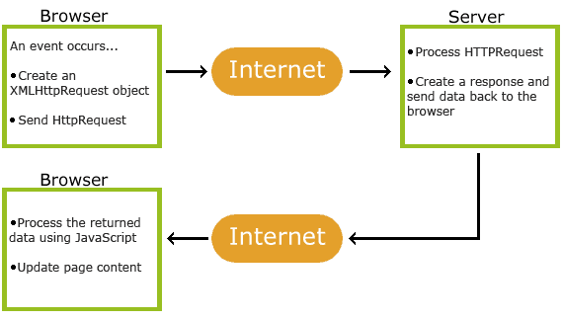

AJAX is based on internet standards, and uses a combination of:

* XMLHttpRequest object (to exchange data asynchronously with a server)
* JavaScript/DOM (to display/interact with the information)
* CSS (to style the data)
* XML (often used as the format for transferring data)

**1.3.3 Overview of Back End**

**MySQL:**

MySQL is the world's most popular open source database software, with over 100 million copies of its software downloaded or distributed throughout it's history. With its superior speed, reliability, and ease of use, MySQL has become the preferred choice for Web, Web 2.0, SaaS, ISV, Telecom companies and forward-thinking corporate IT Managers because it eliminates the major problems associated with downtime, maintenance and administration for modern, online applications.

Many of the world's largest and fastest-growing organizations use MySQL to save time and money powering their high-volume Web sites, critical business systems, and packaged software — including industry leaders such as Yahoo!, Alcatel-Lucent, Google, Nokia, YouTube, Wikipedia, and Booking.com.

The flagship MySQL offering is MySQL Enterprise, a comprehensive set of production-tested software, proactive monitoring tools, and premium support services available in an affordable annual subscription.

MySQL is a key part of LAMP (Linux, Apache, MySQL, PHP / Perl / Python), the fast-growing open source enterprise software stack. More and more companies are using LAMP as an alternative to expensive proprietary software stacks because of its lower cost and freedom from platform lock-in.

MySQL was originally founded and developed in Sweden by two Swedes and a Finn: David Axmark, Allan Larsson and Michael "Monty" Widenius, who had worked together since the 1980's

MySQL is the most popular database system used with PHP.

* MySQL is a database system used on the web
* MySQL is a database system that runs on a server
* MySQL is ideal for both small and large applications
* MySQL is very fast, reliable, and easy to use
* MySQL supports standard SQL
* MySQL compiles on a number of platforms
* MySQL is free to download and use
* MySQL is developed, distributed, and supported by Oracle Corporation
* MySQL is named after co-founder Monty Widenius's daughter: My

The data in MySQL is stored in tables. A table is a collection of related data, and it consists of columns and rows.

We want the MySQL database to be:

* The best and the most-used database in the world for online applications
* Available and affordable for all
* Easy to use
* Continuously improved while remaining fast, secure and reliable
* Fun to use and improve
* Free from bugs

**phpMyAdmin**:

Database can be difficult to manage using just individual SQL statemants.It is much easier to manage a database using a graphical user interace(GUI).One o the best and most popular GUI’s for managing a MySQL database is called phpMyAdmin.Itis a web-based application that makes it easy to manage your MySQL database is called phpMyAdmin.It is a web-based application that makes it easy to manage your MySQL database.phpMyAdmin let you add,remove and manage databases,tables,and entries;backup the database,run specific SQL queries,search and import record and much more.

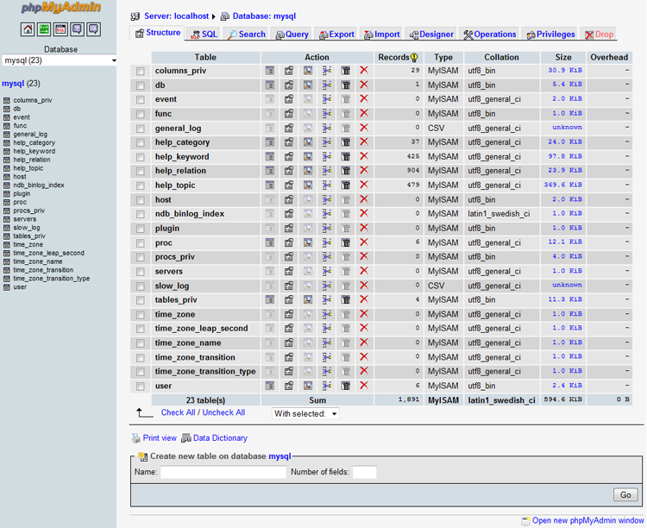

**2. SYSTEM ANALYSIS**

* 1. **Feasibility Study**

Feasibility studiesaim to objectively and rationally uncover the strengths and weaknesses of the existing business or proposed venture, opportunities and threats as presented by the environment, the resources required to carry through, and ultimately the prospects for success. In its simplest terms, the two criteria to judge feasibility are cost required and value to be attained. As such, a well-designed feasibility study should provide a historical background of the business or project, description of the product or service, accounting statements, details of operations and management, marketing research and policies, financial data, legal requirements and tax obligations.

**2.1.1 Technical Feasibility**

The assessment is based on an outline design of system requirements in terms of Input, Processes, Output, Fields, Programs, and Procedures. This can be quantified in terms of volumes of data, trends, frequency of updating, etc. in order to estimate whether the new system will perform adequately or not. Technological feasibility is carried out to determine whether the company has the capability, in terms of software, hardware, personnel and expertise, to handle the completion of the project. When writing a feasibility report the following should be taken to consideration:

* A brief description of the business to assess more possible factor/s which could affect the study
* The part of the business being examined
* The human and economic factor
* The possible solutions to the problems

At this level, the concern is whether the proposal is both *technically* and *legally* feasible (assuming moderate cost).

**2.1.2 Operational Feasibility**

Operational feasibility is a measure of how well a proposed system solves the problems, and takes advantage of the opportunities identified during scope definition and how it satisfies the requirements identified in the requirements analysis phase of system development.

* + 1. **Resource Feasibility**

Resources for Change have a long standing involvement and core interest in the development of projects linked to the countryside and to locally-based eco-tourism. Our philosophy is that successful and sustainable projects can be developed around the particular characteristics and resources of our rural communities, when the local community is fully involved and on board, and where there has been a realistic assessment of the opportunities and economics of the project. In carrying out feasibility studies Resources for Change works hard to consult and involve (in the short or longer term) all stakeholders and to provide a realistic assessment of the options available.

**Software Development Modules**

**Iterative model of Agile**

Agile Project Management is one of the revolutionary methods introduced for the practice of project management. This is one of the latest project management strategies that is mainly applied to project management practice in software development. Therefore, it is best to relate agile project management to the software development process when understanding it.

From the inception of software development as a business, there have been a number of processes following, such as the waterfall model. With the advancement of software development, technologies and business requirements, the traditional models are not robust enough to cater the demands.

Therefore, more flexible software development models were required in order to address the agility of the requirements. As a result of this, the information technology community developed agile software development models.

'Agile' is an umbrella term used for identifying various models used for agile development, such as Scrum. Since agile development model is different from conventional models, agile project management is a specialized area in project management.

The Agile Process:

It is required for one to have a good understanding of the agile development process in order to understand agile project management.

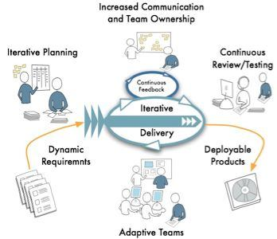

There are many differences in agile development model when compared to traditional models:

* The agile model emphasizes on the fact that entire team should be a tightly integrated unit. This includes the developers, quality assurance, project management and the customer.
* Frequent communication is one of the key factors that make this integration possible. Therefore, daily meetings are held in order to determine the day's work and dependencies.
* Deliveries are short-term. Usually a delivery cycle ranges from one week to four weeks. These are commonly known as sprints.
* Agile project teams follow open communication techniques and tools. These techniques and tools enable the team members (including the customer) to express their views and feedback openly and quickly. These comments are then taken into consideration when shaping the requirements and implementation of the software.

Scope of Agile Project Management:

In an agile project, the entire team is responsible in managing the team and it is not just the project manager's responsibility. When it comes to processes and procedures, the common sense is used over the written policies.

This makes sure that there is no delay is management decision making and therefore things can progress faster.

In addition to being a manager, the agile project management function should also demonstrate the leadership and skills in motivating others. This helps retaining the spirit among the team members and gets the team to follow discipline.

Agile project manager is not the 'boss' of the software development team. Rather, this function facilitates and coordinates the activities and resources required for quality and speedy software development.

Responsibilities of an Agile Project Manager:

Following are the responsibilities of an agile project management function. From one project to another, these responsibilities can slightly change and become interpreted differently.

* Responsible for maintaining the agile values and practices in the project team.
* The agile project manager removes impediments as the core function of the role.
* Helps the project team members to turn the requirements backlog into working software functionality.
* Facilitates and encourages effective and open communication within the team.
* Responsible for holding agile meetings that discusses the short-term plans and plans to overcome obstacles.
* Enhances the tool and practices used in the development process.
* Agile project manager is the chief motivator of the team and plays the mentor role for the team members as well.
* Agile Project Management Does Not:
* Manage the software development team.
* Overrule the informed decisions taken by the team members.
* Direct team members to perform tasks or routines.
* Drive the team to achieve specific milestones or deliveries.
* Assign task to the team members.
* Make decisions on behalf of the team.
* Involve in technical decision making or deriving the product strategy

Below is the Technical Specification for Asset Management System Application’s smooth functioning, which covers hardware and software details

* Processor:Pentium and above.
* RAM :256MB.
* Hard Disk :Free Space 2GB and above.

**3.1.2.2 Software to be used**

* Software : Visual Studio .Net 2012
* Language : PHP
* Database : MySQL
* Operating System : Windows 7,Windows8
* Web Technologies : HTML,CSS,Javascript,Ajax

**3.1.2.3 Tools to be used**

**jQuery**

jQuery is free, open source software, dual-licensed under the MIT License or the GNU General Public License, Version 2. jQuery’s syntax is designed to make it easier to navigate a document, select DOM elements, create animations, handle events, and develop Ajax applications. jQuery also provides capabilities for developers to create plug-ins on top of the JavaScript library. This enables developers to create abstractions for low-level interaction and animation, advanced effects and high-level, theme-able widgets. The modular approach to the jQuery library allows the creation of powerful dynamic web pages and web applications.

jQuery includes the following features:

* DOM element selections using the cross-browser open source selector engine Sizzle, a spin-off out of the jQuery project.
* DOM traversal and modification (including support for CSS 1-3
* DOM manipulation based on CSS selectors that uses node elements name and node elements attributes (id and class) as criteria to build selector
* Events
* Effects and animations
* Extensibility through plug-in
* Utilities - such as user agent information, feature detection
* Compatibility methods that are natively available in modern browsers but need fallbacks for older ones - For example the inArray() and each() functions.
* Cross-browser support

**JavaScript**

Imperative and structured

JavaScript supports much of the structured programming syntax from C (e.g., if statements, while loops, switch statements, etc.). One partial exception is scoping: C-style block-level scoping is not supported (instead, JavaScript has function-level scoping). JavaScript, however, supports block-level scoping with the let keyword. Like C, JavaScript makes a distinction between expressions and statements. One syntactic difference from C is automatic semicolon insertion, in which the semicolons that terminate statements can be omitted.

**Dynamic**

Dynamic typing as in most scripting languages, types are associated with values, not with variables.

**Run-time evaluation**

JavaScript includes an eval function that can execute statements provided as strings at run-time.

**Functional**

First-class functions are first-class; they are objects themselves. As such, they have properties and methods, such as length and call(); and they can be assigned to variables, passed as arguments, returned by other functions, and manipulated like any other object. Any reference to a function allows it to be invoked using the () operator.

**Nested functions and closures**

"Inner" or "nested" functions are functions defined within another function. They are created each time the outer function is invoked. In addition to that, each created function forms a lexical closure: the lexical scope of the outer function, including any constants, local variables and argument values, become part of the internal state of each inner function object, even after execution of the outer function concludes.

**Prototype-based**

JavaScript uses prototypes instead of classes for inheritance. It is possible to simulate many class-based features with prototypes in JavaScript. Functions as object constructors Functions double as object constructors along with their typical role. Prefixing a function call with new creates a new object and calls that function with its local this keyword bound to that object for that invocation.

**Functions as methods**

Unlike many object-oriented languages, there is no distinction between a function definition and a method definition. Rather, the distinction occurs during function calling; a function can be called as a method. When a function is called as a method of an object, the function's local this keyword is bound to that object for that invocation.

**CSS**

Cascading Style Sheets (CSS) is a style sheet language used for describing the presentation semantics (the look and formatting) of a document written in a markup language. Its most common application is to style web pages written in HTML and XHTML, but the language can also be applied to any kind of XML document, including plain XML, SVG

and XUL.CSS is designed primarily to enable the separation of document content (written in HTML or a similar markup language) from document presentation, including elements such as the layout, colors, and fonts.

This separation can improve content accessibility, provide more flexibility and control in the specification of presentation characteristics, enable multiple pages to share formatting, and reduce complexity and repetition in the structural content (such as by allowing for tableless web design). CSS can also allow the same markup page to be presented in different styles for different rendering methods, such as on-screen, in print, by voice (when read out by a speech-based browser or screen reader) and on Braille-based, tactile devices. It can also be used to allow the web page to display differently depending on the screen size or device on which it is being viewed.

**HTML**

Unlike many object-oriented languages, there is no distinction between a function definition and a method definition. Rather, the distinction occurs during function calling; a function can be called as a method. When a function is called as a method of an object, the function's local this keyword is bound to that object for that invocation.HTML5 is a markup language for structuring and presenting content for the World Wide Web, and is a core technology of the Internet originally proposed by Opera Software. It is the fifth revision of the HTML standard (created in 1990 and standardized as HTML4 as of 1997) and, as of May 2012, is still under development. Its core aims have been to improve the language with support for the latest multimedia while keeping it easily readable by humans and consistently understood by computers and devices (web browsers, parsers, etc.).

HTML5 is intended to subsume not only HTML 4, but XHTML 1 and DOM Level 2 HTML as well. Following its immediate predecessors HTML 4.01 and XHTML 1.1, HTML5 is a response to the observation that the HTML and XHTML in common use on the World Wide Web are a mixture of features introduced by various specifications, along with those introduced by software products such as web browsers, those established by common

practice, and the many syntax errors in existing web documents. It is also an attempt to define a single markup language that can be written in either HTML or XHTML syntax.

**3.3.2 Object Oriented Analysis & Design Diagrams**

**3.3.2.1 “UML Diagrams”**

**Class Diagram**



**Use Case Diagram:**

**Usecase for Visitor**



**Usecase for members**



**Activity Diagram**

**Activity for Login member**



**Activity for visitor**



**Sequence Diagram**



**Collaboration Diagram**

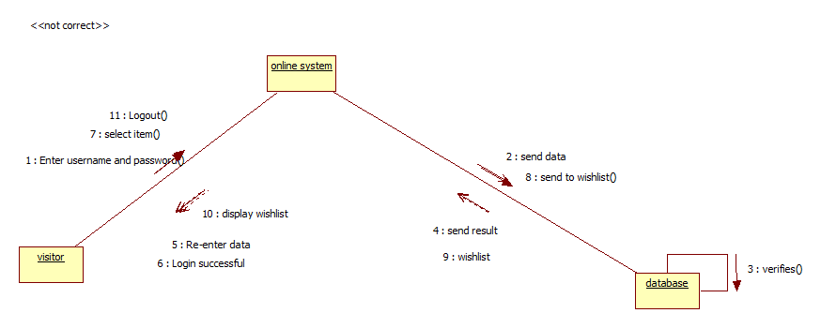

**Component Diagram**



**Deployment Diagram**



**DataFlow Diagrams:**

**Context Level diagram**

**DFD**

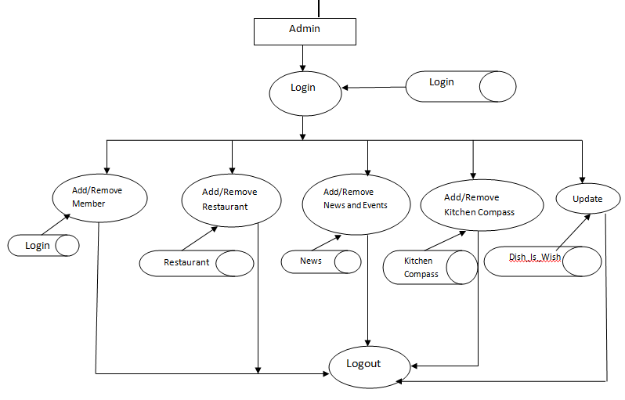

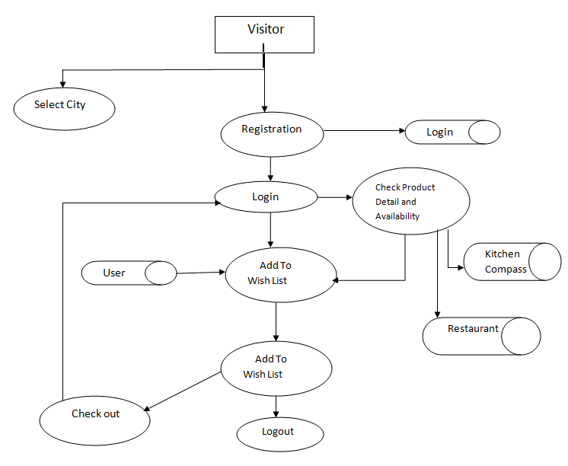

**E-R Diagram**

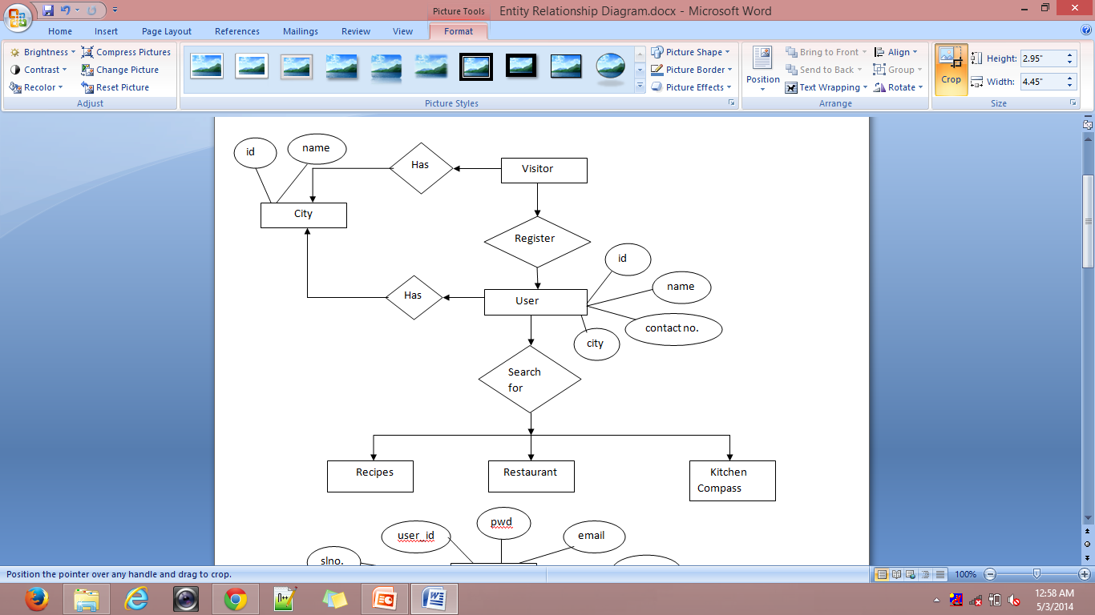

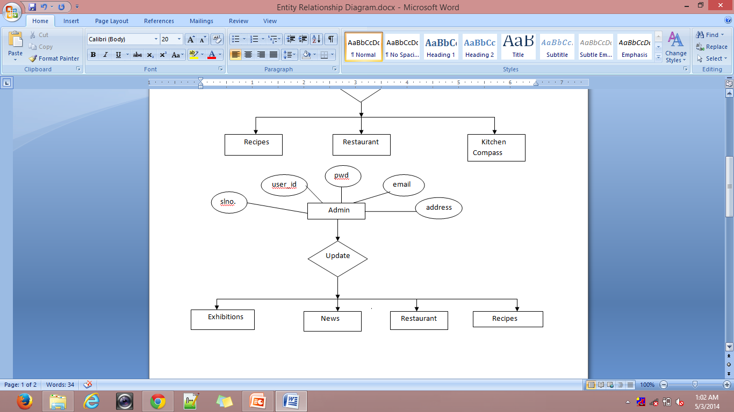

**3.3.3 Database**

**3.3.3.1 Database Table**

**4. Testing Report**

**4.1Methodologies used for Testing**

Software testing is an integral part of the software development life cycle (SDLC).

Testing a piece of code effectively and efficiently is equally important, if not more, to writing it. So what is software testing? Well, for those who are new to software testing and quality assurance, here are few useful facts. Software testing is nothing but subjecting a piece of code to both, controlled and uncontrolled operating conditions, in an attempt to observe the output and examining whether it is in accordance with certain pre-specified conditions.

Different sets of test cases and testing strategies are prepared, all of which are aimed at achieving one common goal i.e. removing bugs and errors from the code and making the software error-free and capable of providing accurate and optimum outputs. There are different types of software testing techniques and methodologies. A software testing methodology is different from a software testing technique. We'll take a look at few of the software testing methodologies in the latter part of this article.

**Software Testing Methodology**

**V Model**

The issues seen in the traditional waterfall model gave birth to the V-Model;

It was developed with an intention to address some of the problems found in waterfall model. As you can see that in waterfall model defects were found very late in the development life cycle because testing was not involved until the end of the project.

In V-Model testing begins as early as possible in the project life cycle, it is always a good practice to involve testers at earlier phases of product life cycle. There are varieties of test activities that need to be carried out before end of the coding phase. These activities should be carried out in parallel to the development activities so that testers can produce a set of test deliverables.

The V-Model illustrates that testing activities (Verification and Validation) can be integrated into each phase of the product life cycle. Validation part of testing is integrated in the earlier phases of the life cycle which includes reviewing end user requirements, design documents etc. There are variants of V-Model however we will take a common type of V-model example.

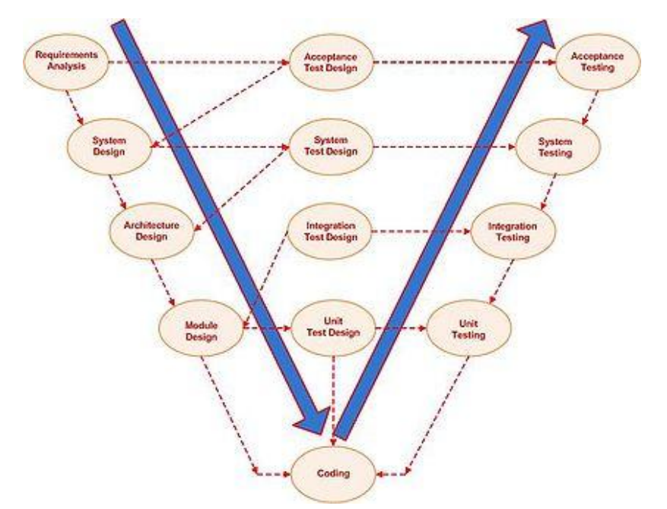

The V-model generally has four test levels

.

* Component Testing
* Integration Testing
* System Testing
* Acceptance Testing

**Advantages**

* Each phase has specific deliverables.
* Higher chance of success over the waterfall model due to the development of test plans early on during the life cycle.
* Time concern in comparison with the waterfall model is low or even we can say 50% less.
* Works well for small projects where requirements are easily understood.
* Utility of the resources is high.

**Disadvantages**

* Very rigid, like the waterfall model.
* Little flexibility and adjusting scope is difficult and expensive.
* Software is developed during the implementation phase, so no early prototypes of the software are produced.
* Model doesn’t provide a clear path for problems found during testing phases

**4.2 Types of Testing**

**4.2.1 White Box Testing**

White box testing strategy deals with the internal logic and structure of the code. It is also called glass, structural, open or clear box testing. The tests that are written based on the white box testing strategy incorporate coverage of the code written, branches, paths, statements and internal logic of the code, etc. In order to implement white box testing, the tester has to deal with the code, and hence is required to possess knowledge of coding and logic i.e., internal working of the code. White box test also needs the tester to look into the code and find out which unit/statement/chunk of the code is malfunctioning. In other words, it is imperative that the tester has 'structural' knowledge about how the system has been implemented. Not only the code, but even the data flow and control flow have to be assessed. The areas of the code that are tested using white box testing are:

1. Code Coverage

2. Segment Coverage

3. Branch Coverage

4. Condition Coverage

5. Loop Coverage

6. Path Testing

7. Data Flow Coverage

There are three aspects of the code, which are validated in white box testing, namely

1. If the software has been designed as per the original design of the software.

2. If security measures have been implemented into the software and it is robust.

3. Find out vulnerabilities in the said software.

**Advantages of White Box Testing**

* + As the knowledge of internal coding structure is prerequisite, it becomes very easy to find out which type of input/data can help in testing the application effectively.
  + Yet another advantage of white box testing is that it helps in optimizing the code.
  + It helps in removing the extra lines of code, which can introduce defects in the code.

**Disadvantages of White Box Testing**

* + As knowledge of code and internal structure is a prerequisite, a skilled tester is needed to carry out this type of testing, and this, in turn, increases the cost of the software.
  + It is nearly impossible to look into every bit of code to find out hidden errors, which may create problems, resulting in failure of the application.

**4.2.2 Black Box Testing**

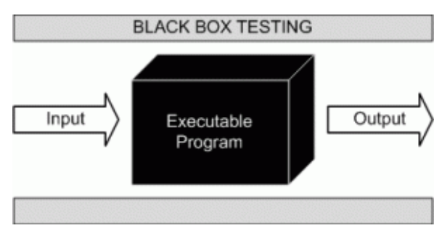

Black box testing is not a type of testing; it instead is a testing strategy, which does not need any knowledge of internal design or code, etc. As the name "black box" suggests, not knowledge of internal logic or code structure is required. The types of testing under this strategy are totally based/focused on the testing for requirements and functionality of the work product/software application. Black box testing is sometimes also called "Opaque Testing",

"Functional/Behavioral Testing" and "Closed Box Testing".

**These testing types are again divided in two groups:**

1. Testing in which the user plays a role of tester

2. User is not required

**4.3 Test Cases**

While testing a Website development application we need to consider following cases:

**4.3.1 Functionality Testing**

In functionality testing we have conducted following tests

* + **Web Forms**

i. Field validation

ii. Error message for wrong input

iii. Optional and Mandatory fields

**4.3.2 Usability Testing**

Usability testing is the process by which the human-computer interaction characteristics of a system are measured, and weaknesses are identified for correction.

* + - Ease of learning
    - Navigation
    - Subjective user satisfaction
    - General appearance

**Database**

Testing will be done on the database integrity

**4.3.3 Performance Testing**

Performance testing can be done to check the performance of the system in other operating environment. Here we have check how it is operated in other versions of the Internet Explorer, Google Chrome and Firefox and other configurations of the system

|  |  |  |  |  |  |
| --- | --- | --- | --- | --- | --- |
| **Test Case No** | **Purpose** | **Step to be Executed** | **Expected Result** | **Actual Result** | **Pass/ Fail** |
| 1. | Validation for | 1) Enter the valid data in email id Textbox.  2) Enter the valid data in Password textbox.  3)Click on Login Button | User Should be entering in Application | User is entering in Application | Pass |
| 2. | Validation for ‘Password’ field | 1) Enter the Invalid data in email id textbox.  2) Enter the valid data in Password textbox.  3)Click on Login Button | User Should be entering in Application | User is not entering  Application | Pass |
| **3.** | Validation for ‘Invalid Email Id’ field | 1)Enter the Invalid data in email id text box  2) Enter the valid data in Password textbox.  3) Click on Login Button | User Should be entering in Application | User is entering in Application | Pass |
| **4.** | Validation for ‘Invalid Password’ field | 1) Enter the valid data in email id text box.  2) Enter the Invalid data in Password textbox.  3)Click on Login Button | User Should be entering in Application | User is not entering in Application | Pass |
| **5.** | Creating new user | 1)Enter valid information in all textboxes  2)Click on Save button | User should be created | User should not be created | Fail |

**5. System Implementation**

**5.1 Hardware requirement at Client Side**

* + Hard Disk :Free Space 2GB and more
  + Processor speed 250 MHz and more

The processor does all the processing for the contents of the program and when the clock speed increases so does the processing speed.

* + RAM 256 and more.

The memory selection is done and preferred for higher memory because the program before running is flushed into memory buffer of computer, then it is executed. More the memory, more will be the speed and hence less time for execution.

**5.2 Software requirement at Client Side**

Software plays an important role in any project development. One should understand that which software he/she should use to develop the project. Window XP was used as the operating system.

The application has been developed using:

* Internet Connection on any Computer.

**5.3 Testing done as End User**

An alpha test is a preliminary software field test carried out by a team of users in order to find bugs that were not found previously through other tests. The main purpose of alpha testing is to refine the software product by finding (and fixing) the bugs that were not discovered through previous tests.

The team that conducts the alpha test is often an independent test team, perhaps made up of potential users/customers. Alpha testing involves simulating a real user environment by carrying out tasks and operations that the actual users might perform. Once software passes the alpha test, it is considered for the next phase of testing called beta testing. The meaning of alpha also can differ based on whether the project is custom software one for a client. In this case, alpha testing implies an initial meeting between software vendor and client to ensure that the client's requirements are properly met by the developer in terms of the performance, functionality and durability of the software program. Compare this versus the context of a web application, where alpha testing can be interpreted as an online application that isn't completely ready for usage, but that has been opened up to get some initial feedback. Commonly an alpha might allow power users to get their first look at the system via a private invitation. The meaning of alpha also can differ based on whether the project is custom software one for a client. In this case, alpha testing implies an initial meeting between software vendor and client to ensure that the client's requirements are properly met by the developer in terms of the performance, functionality and durability of the software program

**6. System Maintenance and Evaluation**

**6.1 Maintenance**

The term maintenance, when accompanied to software, assumes a meaning profoundly different from the meaning it assumes in any other engineeringdiscipline. In fact, many engineering disciplines intend maintenance as the process of keeping something in working order, in repair. The key concept is the deterioration of an engineering artifact due to the use and the passing of time; the aim of maintenance is therefore to keep the artifact’s functionality in line with that defined and registered at the time of release. Of course, this view of maintenance does not apply to software, as software does not deteriorate with the use and the passing of time.

A predominant proportion of changes are to meet ever changing user needs. This is captured by the first law of Lehman: “A program that is used in a real world environment necessarily must change or become progressively less useful in that environment”. Significant changes also derive from the need to adapt software to interact with external entities, including people, organizations, and artificial systems.

Software maintenance is a very broad activity often defined as including all work made on a software system after it becomes operational. This covers the correction of errors, the enhancement, deletion and addition of capabilities, the adaptation to changes in data requirements and operation environments, the improvement ofperformance, usability, or any other quality attributes. The IEEE definition is as follows:

“Software maintenance is the process of modifying a software system orComponent after delivery to correct faults, improves performances or other attributes, or adapt to a changed environment.”This definition reflects the common view that software maintenance is a post-deliveryactivity: it starts when a system is released to the customer or user and encompasses all activities that keep the system operational and meet the user’s needs Software maintenance activities are classified into following four classes:

1. **Adaptive -** modifying the system to cope with changes in the software environment
2. **Perfective** - implementing new or changed user requirements which concernfunctional enhancements to the software

**3. Corrective -** diagnosing and fixing errors, possibly ones found by users

**4. Preventative -** increasing software maintainability or reliability to prevent problems in the future

Application performance has top most priority these days, as organization face tremendous customer demands and competitions in the entire business sector. Application maintenance is a challenging job for any software solution. Over a period of usage, the application may run out of performance due to unexpected problems .Based on user experience there could be suggestions for changes on the functionalities or mode of operation. Also for enterprise applications there may require emergency updates due to unexpected business requirements. All these come under software application maintenance namely preventive maintenance and scheduled maintenance. Preventive maintenance is performed based on the analysis of modules or product before it fails for effective operations.

There are many underlying factors that need to be taken care of while providing an application. The constant support and maintenance services, of course, are top priority.

Defect free system:

We provide 100% error free application to our clients all over the world.

We understand the requirements at all user levels of our clients.

Technical and functional expertise:

We have the rich technology blended technical and functional expertise to maintain the scalability, stability and strategy of business process to keep them up to date.

**Cost effective:**

The software models that we have delivered ensures, cost effectiveness in all ways.

**Flexibility to change:**

The application maintenance services, sometimes requires the system to undergo sufficient changes.

**6.2 Evaluation**

In the present day market situation, there are several alternatives available when a customer wants to purchase a product or adopt a software system that meets the customer’s requirements. Software technologies have been evolving rapidly and for a given set of functional and non-functionalrequirements there usually exist several competing software products. The present day users are faced with a challenging situation that requires evaluation and selection of a suitable software product that satisfies the users’ operational and business needs. Unfortunately this evaluation is usually carried on in anad-hoc and informal way and with various degree of success.

Software evaluation methodologies can be divided into two categories.

The First category is used to evaluate software development methodology or processes such as those used to evaluate variousagent-based development methodologies.

The Second category is used to evaluate software products such as Cost evaluation and selection methodologies.

System Evaluation recognizes and integrates the important features of other frameworks, overcomes any obvious deficiencies, and adopts new features that generalize and extend its usability.

The evaluation stage of the software development process requires the client and developer to review the software.

Broadly speaking, they evaluate against the following questions:

1. Does this software meet the user requirements?

2. Is it fit for purpose?

**Evaluation - Criteria:**

To answer these questions, the original aims of the software must be evaluated against the

Following criteria:

1. Robustness

2. Reliability

3. Portability

4. Efficiency

5. Maintainability

.

**7. User / Operational Manual**

1) This is a guide for the user of this system.

2) This contains all the relevant screen display that will help the user to understand the system.

3) There are proper uses of comments that will help the user to understand in case of error.

4) Proper validation is done and message box are prompted to the user before entering data into the database.

5) The comments describe what exactly the code block does.

**7.1 Security Aspects, Access Rights**

Does the protect itself and its data against unauthorized access and use? Does it allow its operator to enforce security policies? Are appropriate security mechanisms in place? Are those security mechanisms implemented correctly? Can the software withstand attacks that must be expected in its intended environment? Is the software free of errors that would make it possible to circumvent its security mechanisms? Does the architecture limit the impact of yet unknown errors? Security testing is any develop system is about finding loops and weaknesses of the system

There are two types of the user who can access the GPS Tracking System, they are:

* Administrator
* Normal User

Administrator has a right to access all the web forms of the project.

Normal user also has the permission to access the web forms of the Details Menu and the information about the hotels, restaurant, and recipes.

**User's perspective:**

In addition to the technical qualities of software, the end user's experience also determines the quality of software. This aspect of software quality is called usability. It is hard to quantify the usability of a given software product. Some important questions to be asked are:

* Is the user interface intuitive?
* Is it easy to perform easy operations?
* Is it feasible to perform difficult operations?
* Does the software give sensible error messages?
* Do widgets behave as expected?
* Is the software well documented?
* Is the user interface self-explanatory/ self-documenting?
* Is the user interface responsive or too slow?

Also, the availability of (free or paid) support may determine the usability of the software.

**7.2 Back Up’s**

In information technology, backup refers to making copies of data so that these additional copies may be used to restore the original after a data loss event. These additional copies are typically called "backups." Backups are useful primarily for two purposes. The first is to restore a state following a disaster (called disaster recovery). The second is to restore small numbers of files after they have been accidentally deleted or corrupted. Backups are typically that last line of defense against data loss, and consequently the least granular and the least convenient to use.

Since a backup system contains at least one copy of all data worth saving, the data storage requirements are considerable. Organizing this storage space and managing the backup process is a complicated undertaking. There are also many different ways in which these devices can be arranged to provide geographic redundancy, data security, and portability. Before data are sent to their storage location, they are selected, extracted, and manipulated.

Many organizations and individuals try to have confidence that the process is working as expected and work to define measurements and validation techniques. It is also important to recognize the limitations and human factors involved in any backup scheme.

Due to a considerable overlap in technology, backups and backup systems are frequently confused with archives and fault-tolerant systems. Backups differ from archives in the sense that archives are the primary copy of data and backups are a secondary copy of data. Backup systems differ from fault-tolerant systems in the sense that backup systems assume that a fault will cause a data loss event and fault-tolerant systems assume a fault will not.

* + Database Backups is taken by Admin on weekly basis.
  + Backups help in Data Integrity.

**7.3 Screen Shots**

**Index.php**

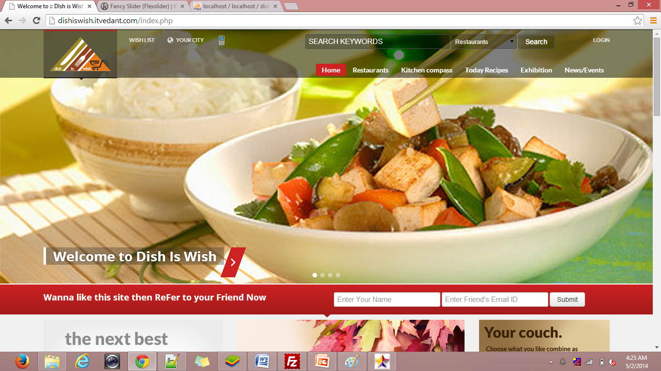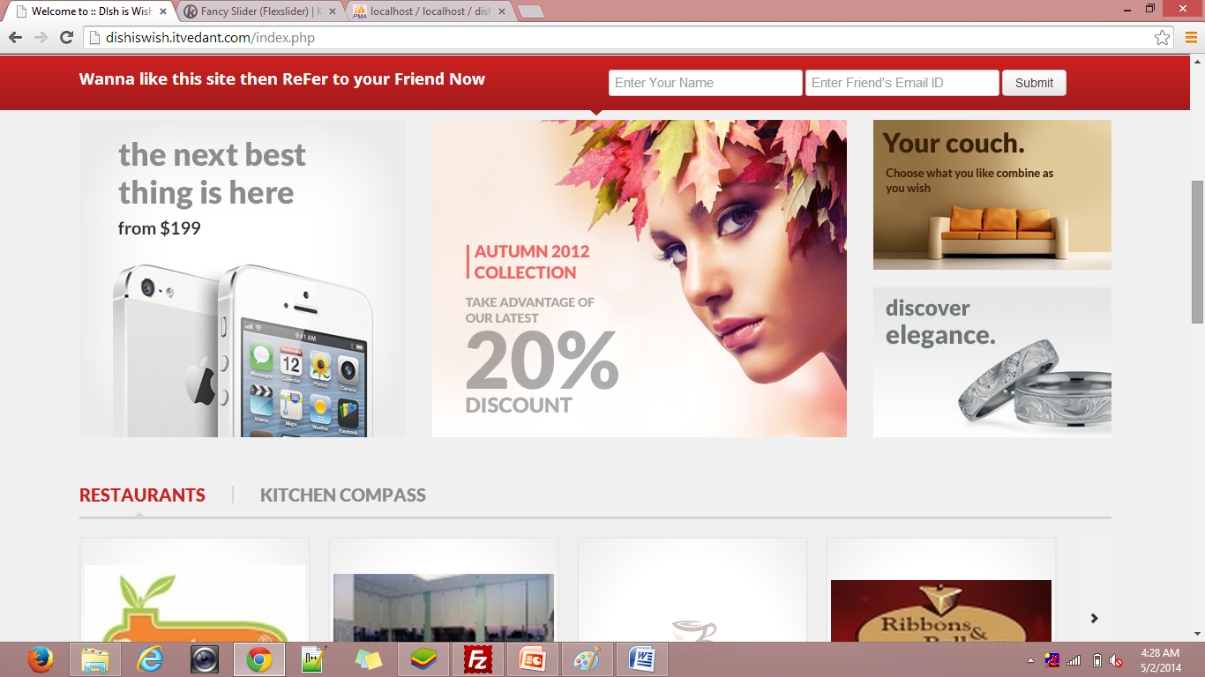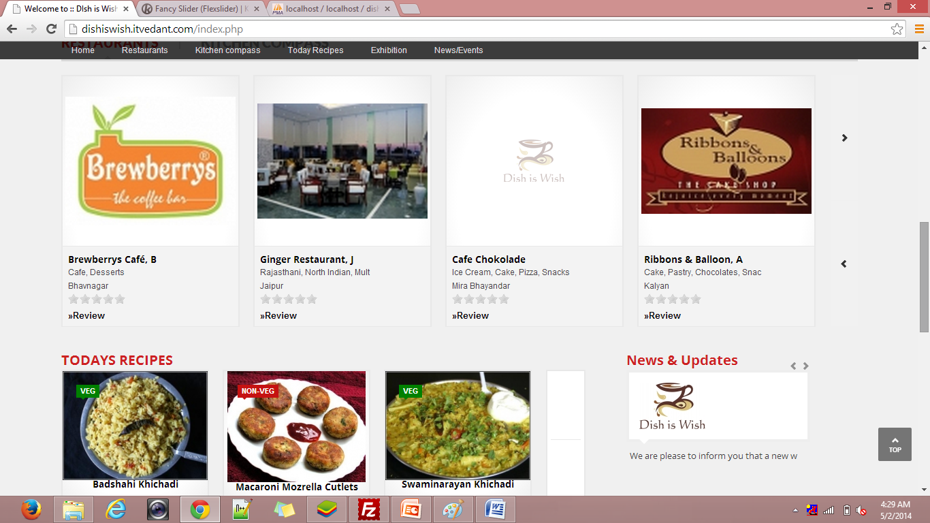

**Restaurant_detail1.php** 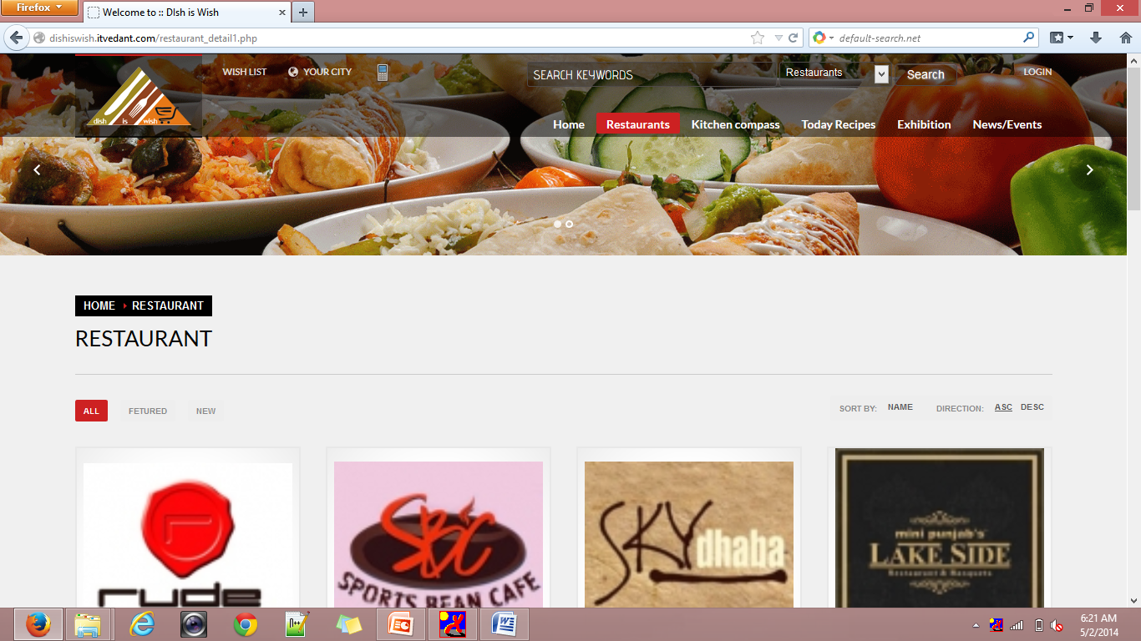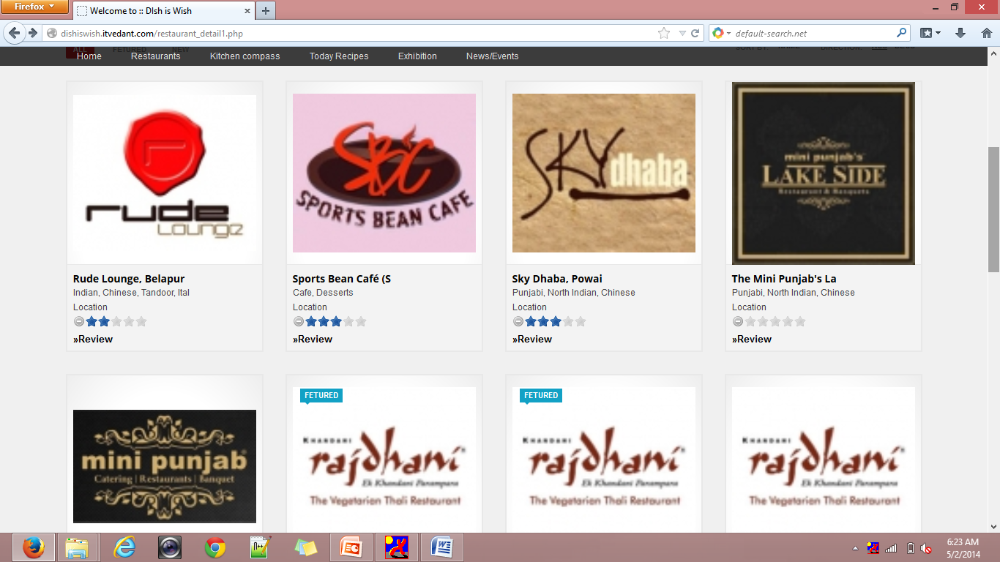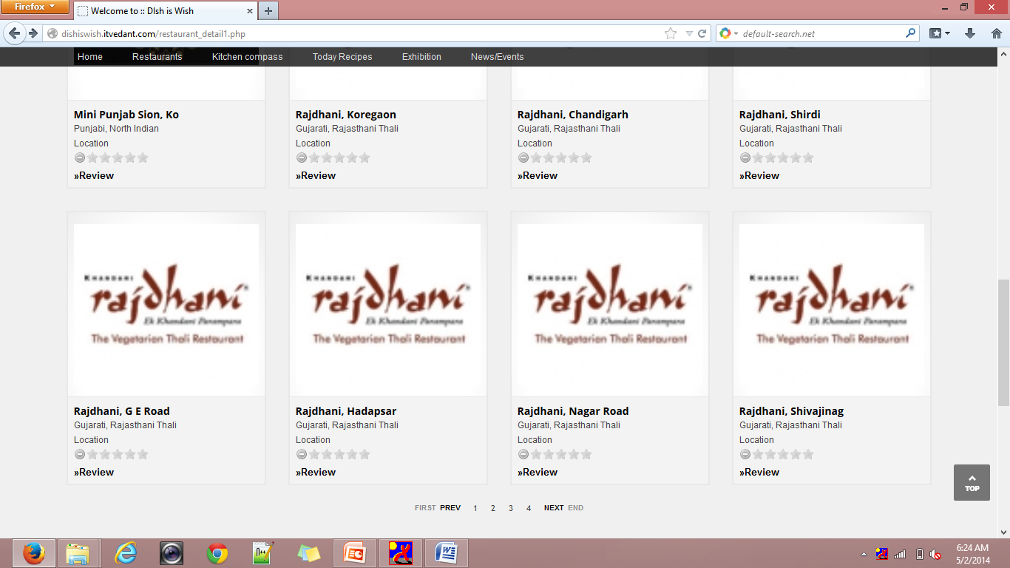

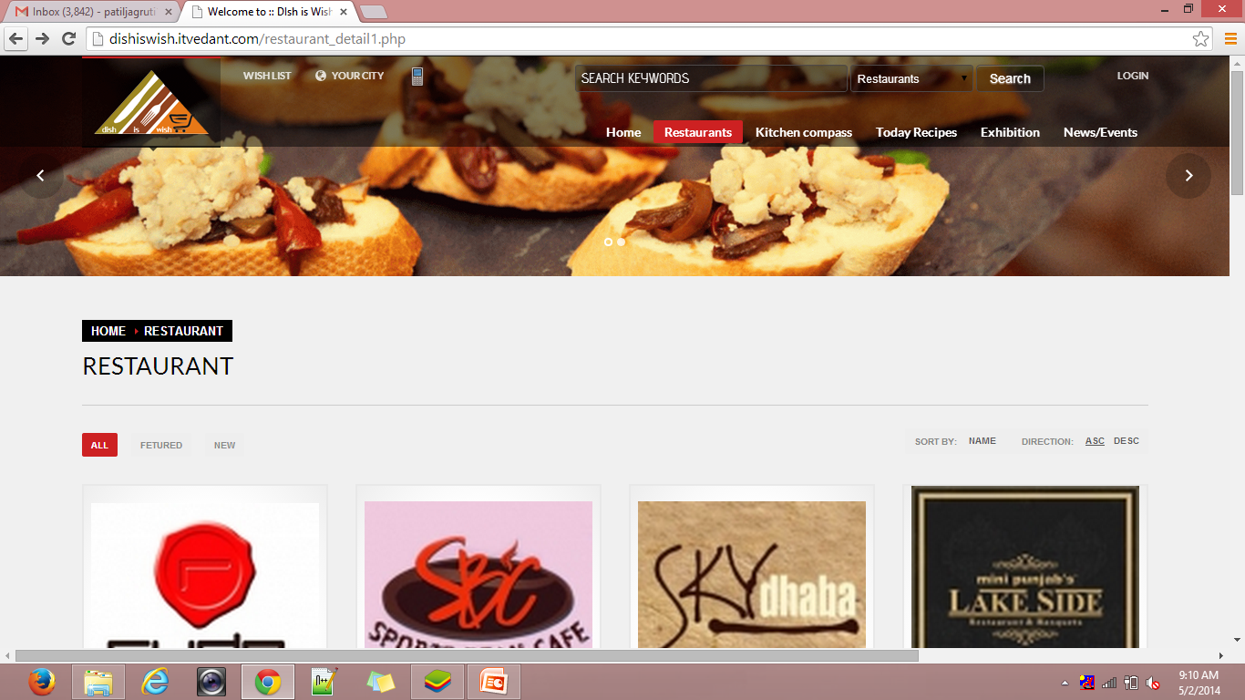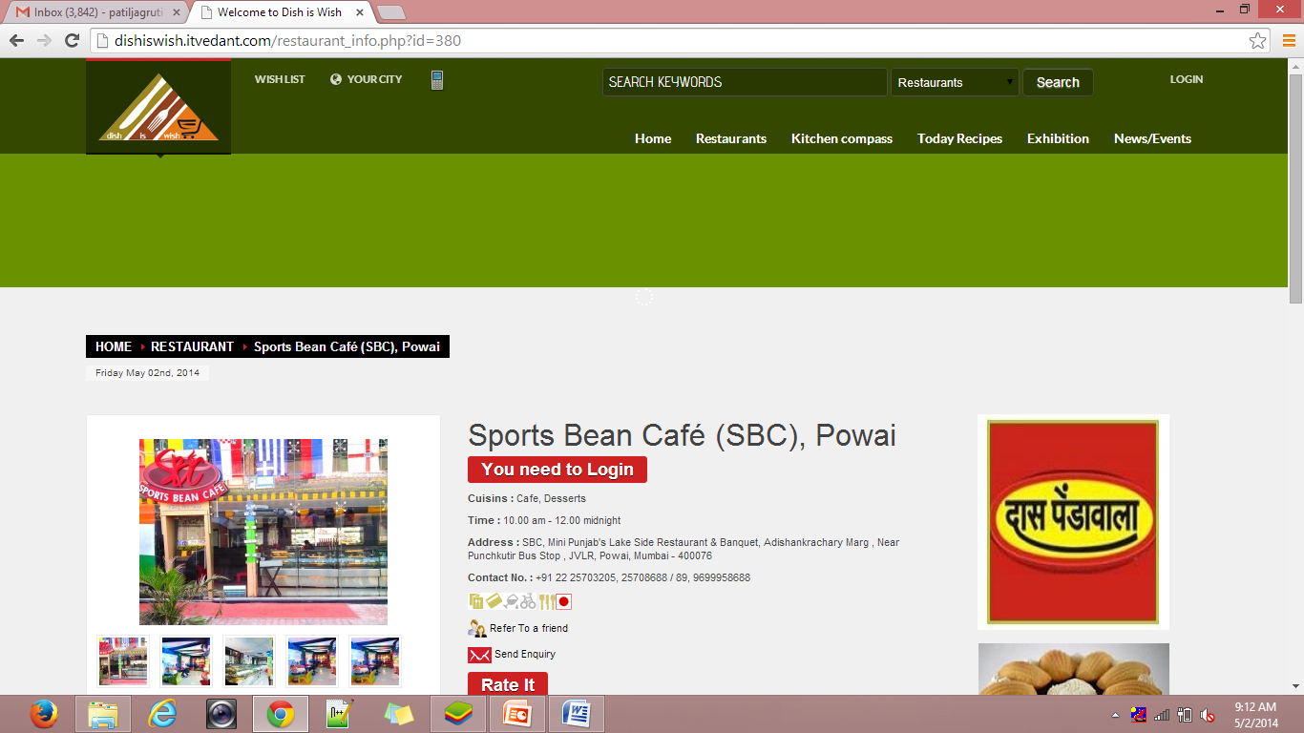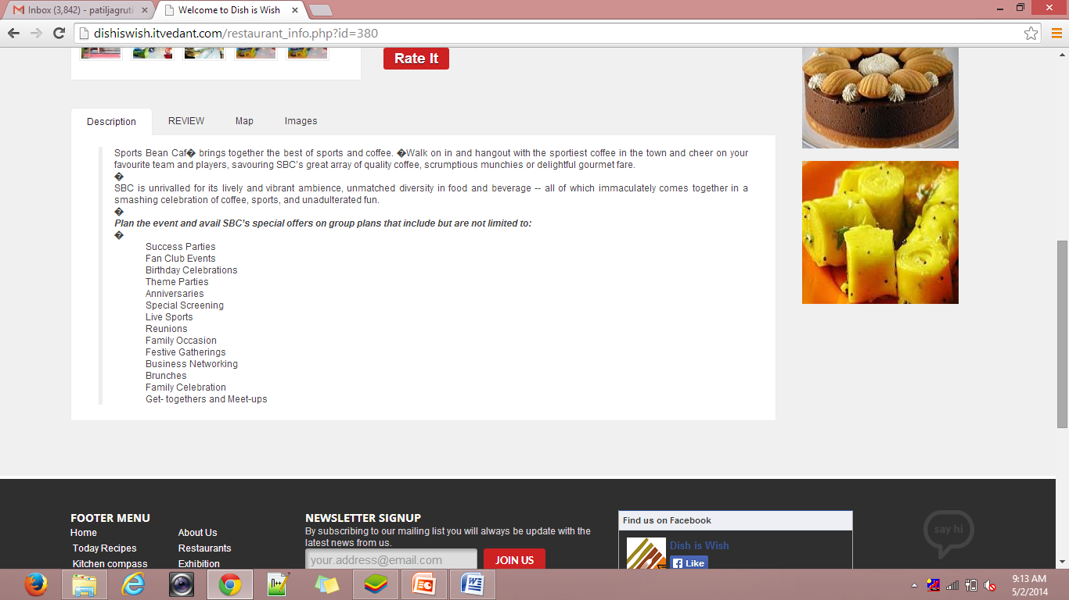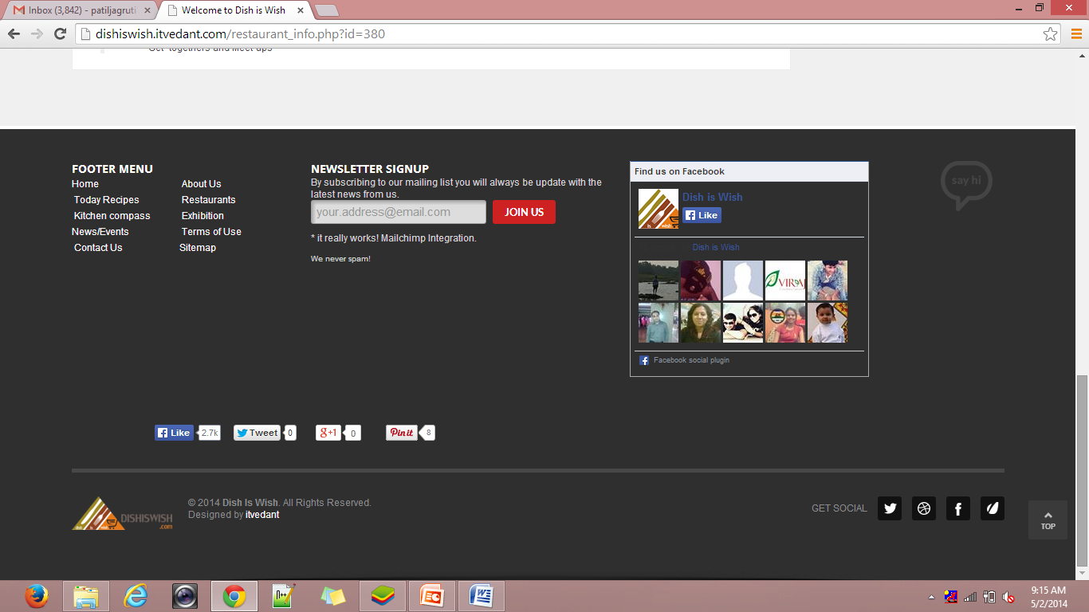

**Restaurant_info.php**

**Login-panel**

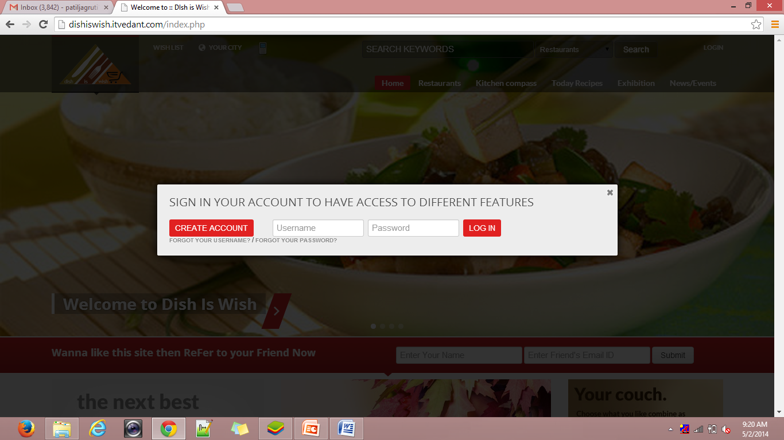

**Register-panel**

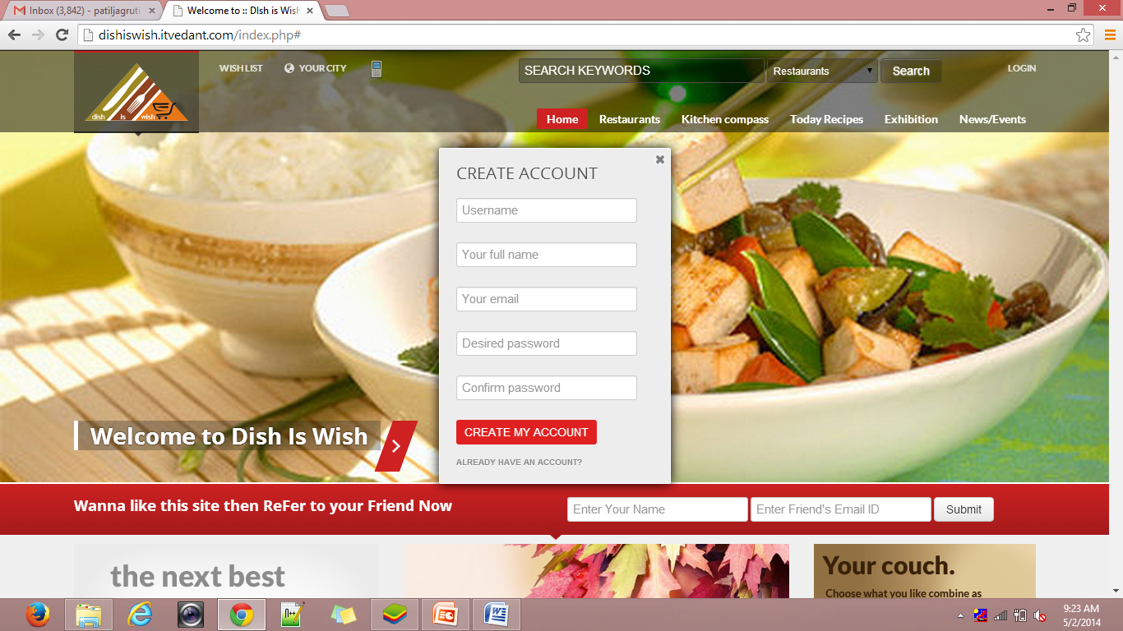

**Contact_us.php**

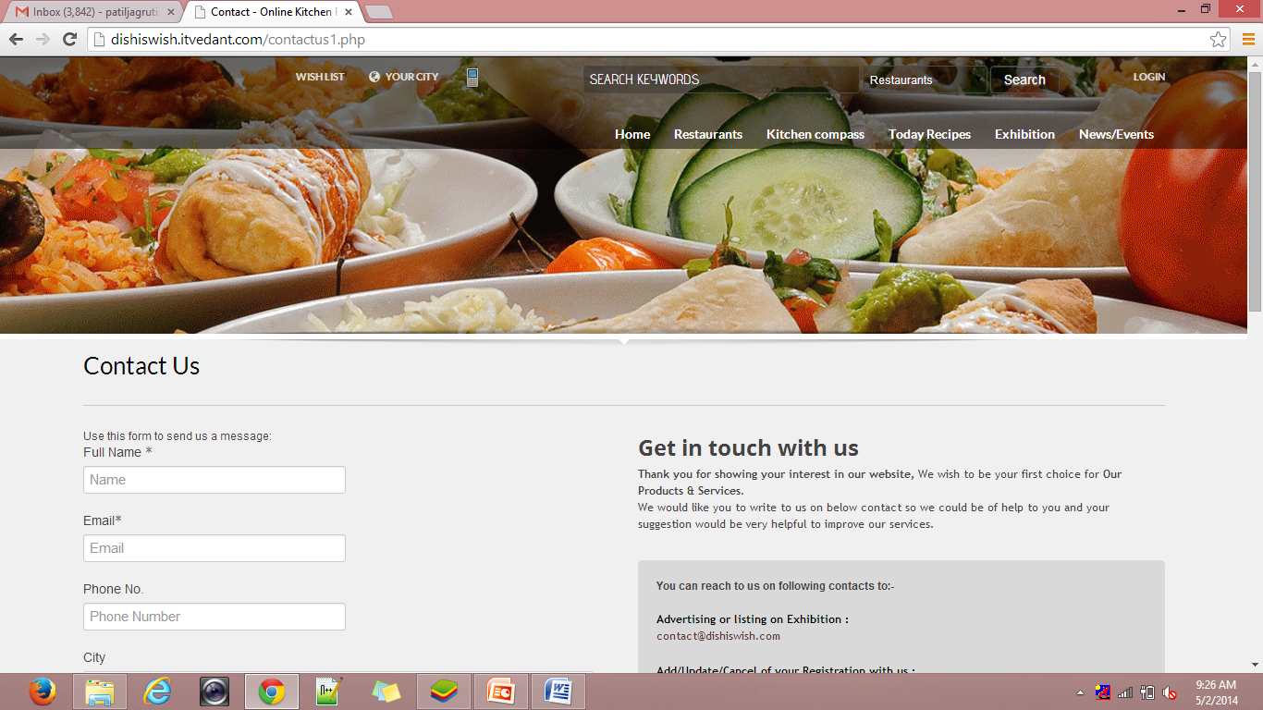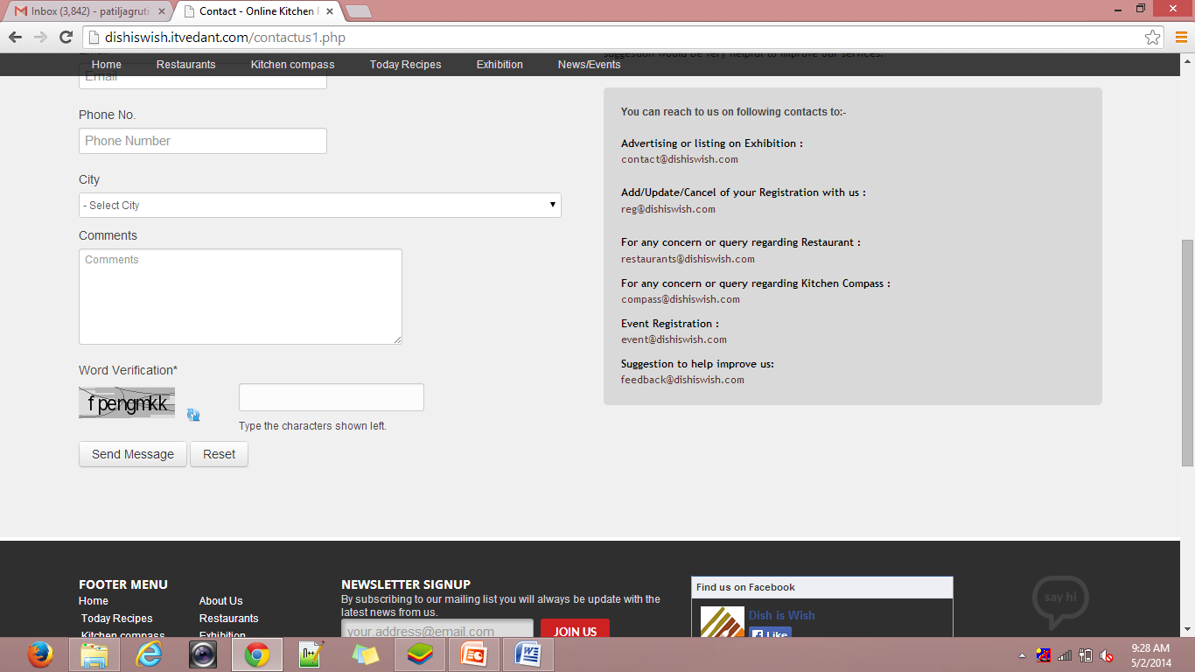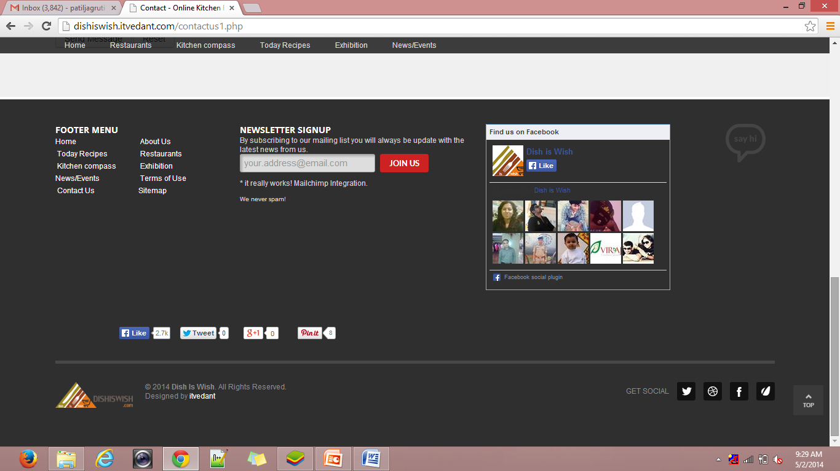

**sitepanel**

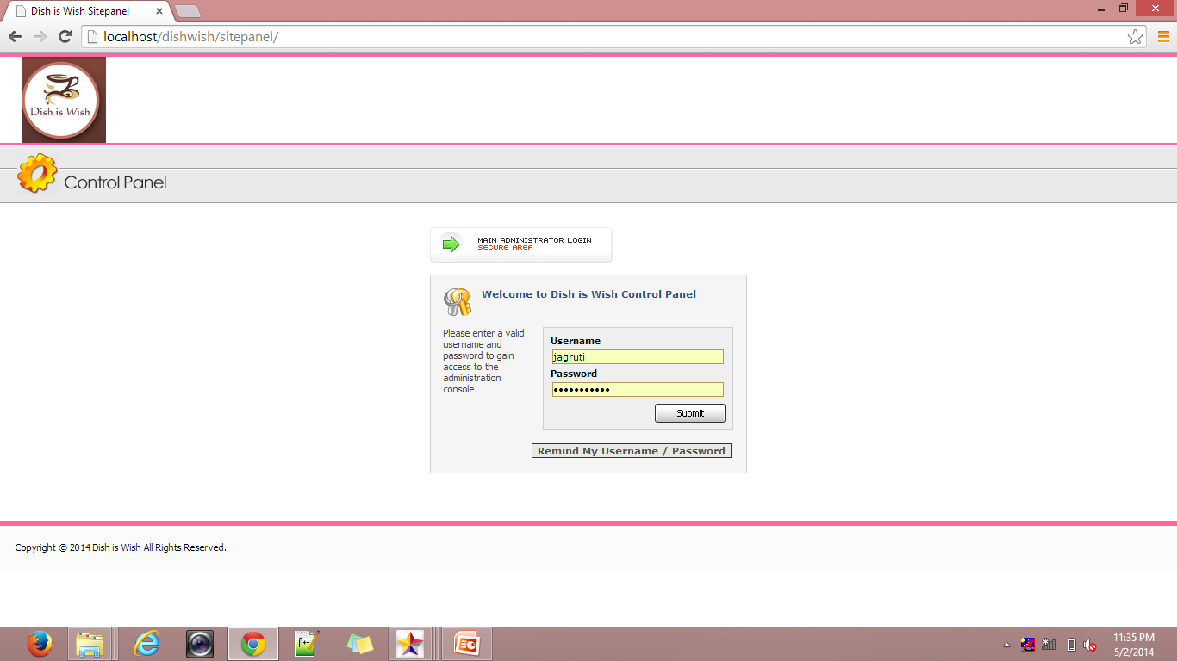

**welcome.php**

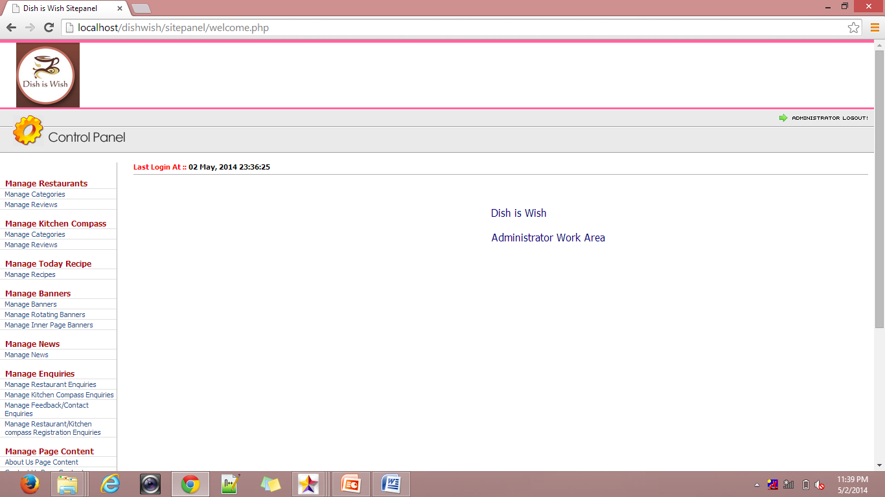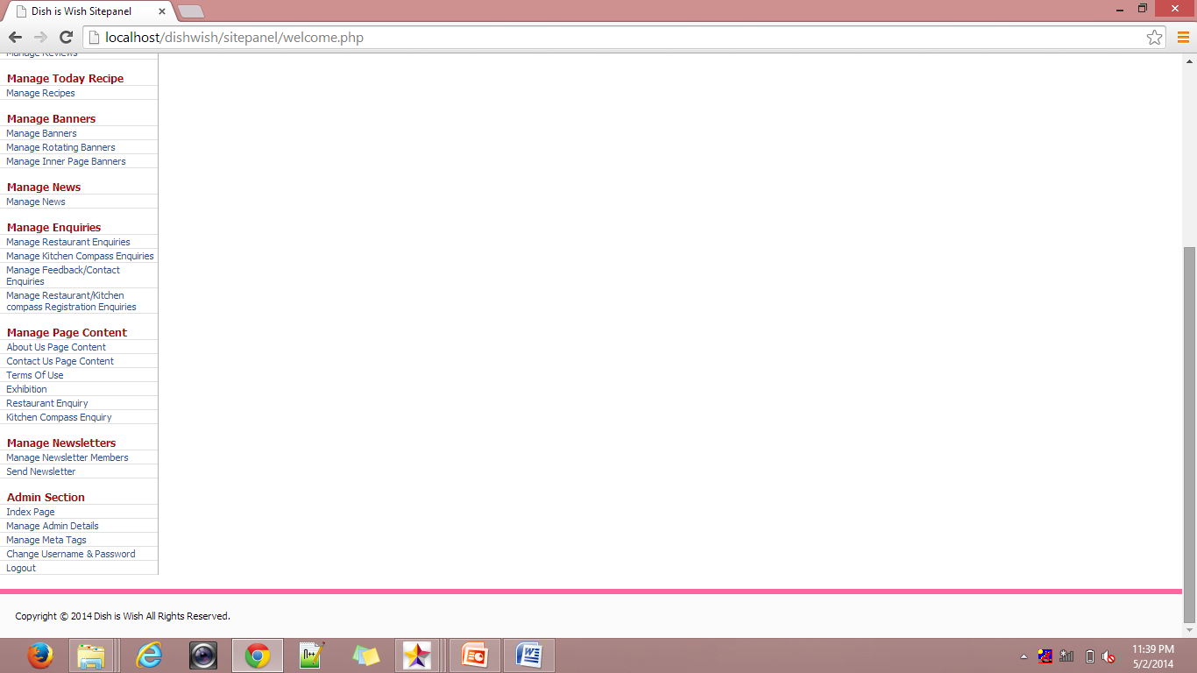

**restaurant.php**

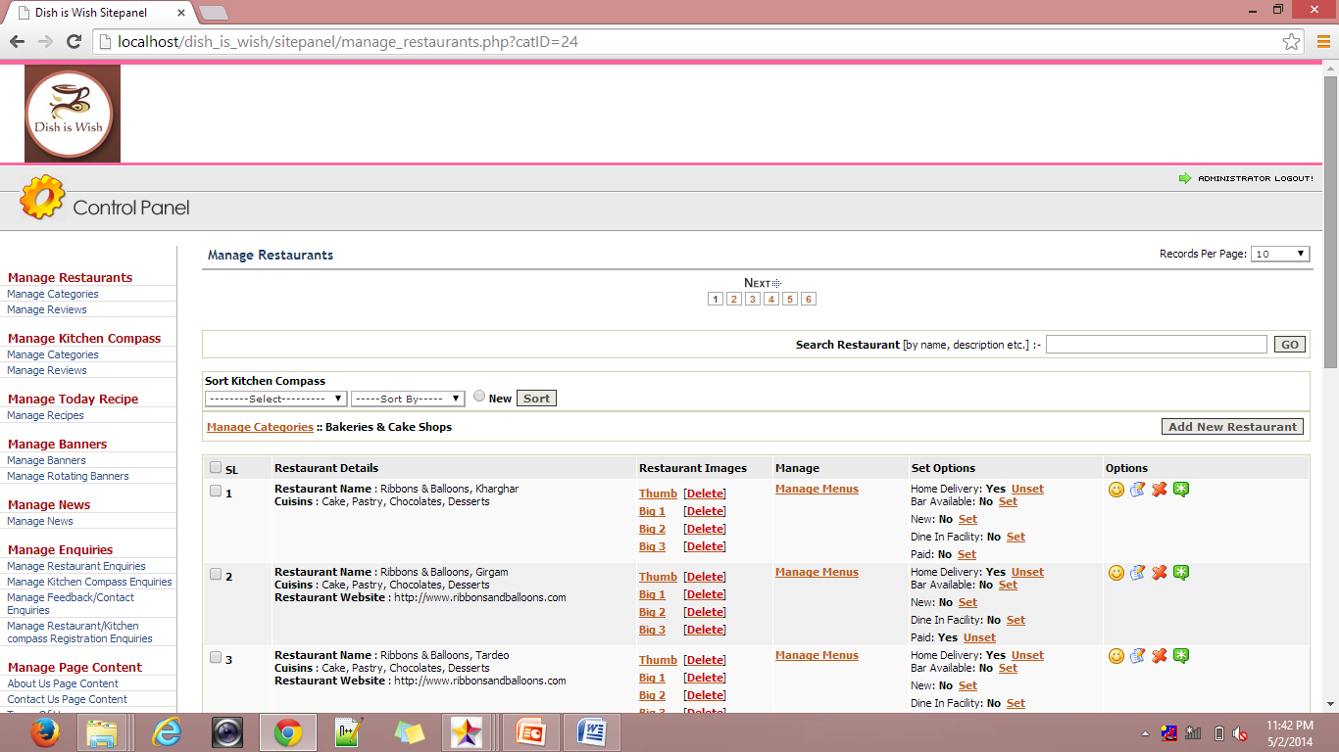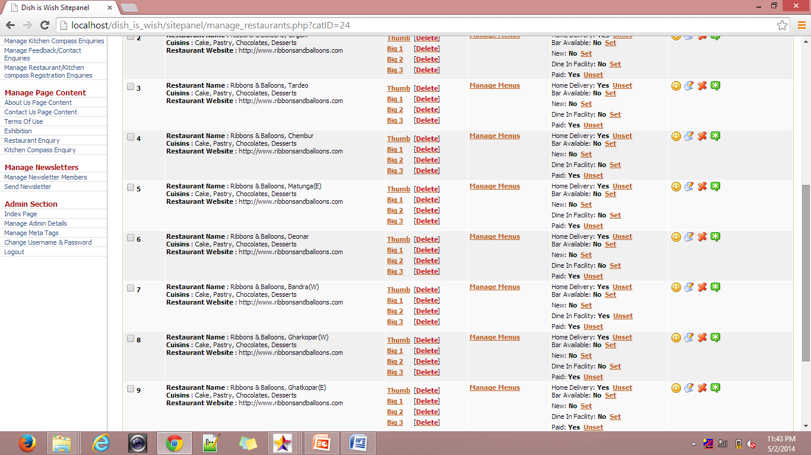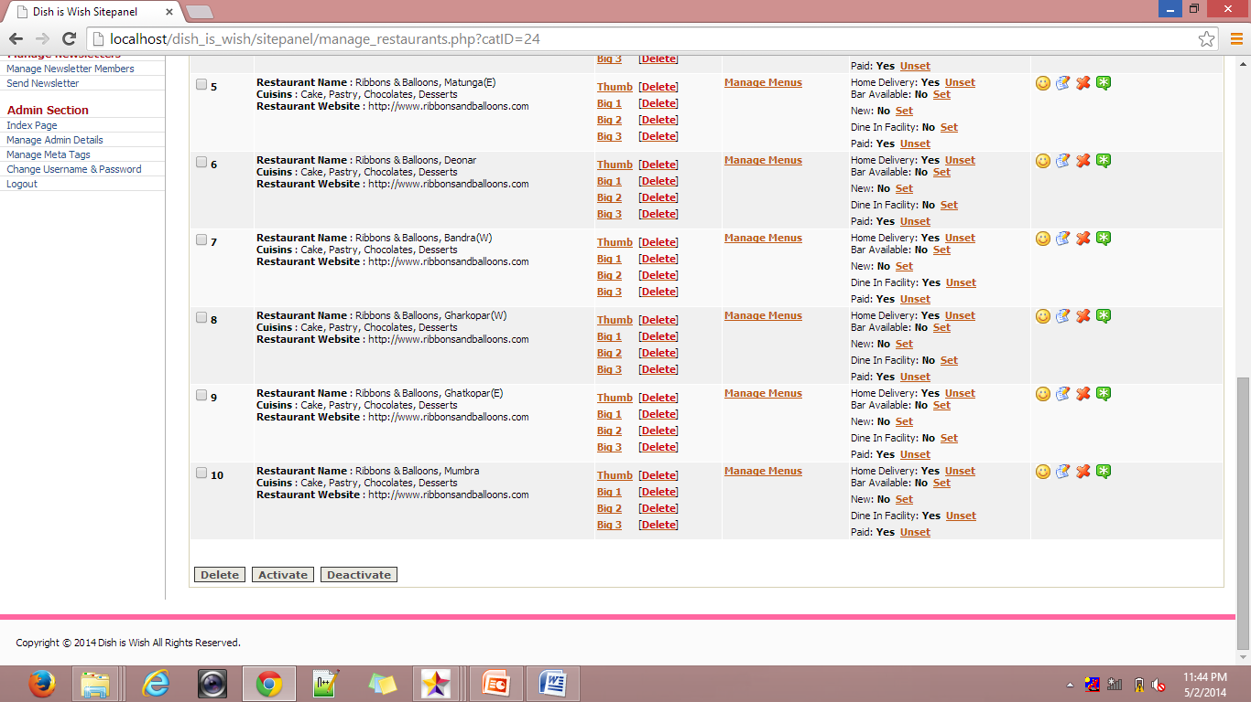

**8. Future Enhancement**

The future enhancements that can be applied to the website are as follows:

Location Tracking can be use to search the restaurants and Kitchen products

* **Loca**

**9. Limitations**

The limitations of the website are as follows:

* The user has to be computer literate.
* Website will not work in case of internet unavailability
* The website will not work in case of power failure or disconnect the internet

.

**10.CONCLUSION**

To display things on the website i.e all information about the hotels, restorant, and any recepies with address, phone number in any time any place.

The objective of this project was to build the website for all information for hotels, restaurant, recepies with address in one place, any time. The website developed is able to meet all the basic information hotels, restaurant, recepies with address in one place, any time.

. The important thing is that the website should be flexible enough for future modifications. The website has been factored into different modules to make system adapt to the further changes. Every effort has been made to cover all user requirements and make it user friendly.

Goal achieved: The website is able provide the interface to the owner so that he can replicate his desired data.

User friendliness: Though the most part of the website is supposed to act in the background, efforts have been made to make the foreground interaction with user (owner) as smooth as possible. Also the integration of the existing system with the project has been kept in mind throughout the development phase.

**11. Bibliography**

**Books**

* [**PHP and MYSQL for Dummies**](http://www.amazon.com/exec/obidos/ASIN/0764516507/ref=nosim/forlagetadland00) by Valade.John Wiley & Sons Inc. Paperback- 30 April, 2002
* [**PHP Bible**](http://www.amazon.com/exec/obidos/ASIN/0764549553/ref=nosim/forlagetadland00) by Converse.John Wiley & Sons Inc. Paperback- 4 October, 2002.
* [**Core PHP Programming**](http://www.amazon.com/exec/obidos/ASIN/0130893986/ref=nosim/forlagetadland00) by Leon Atkinson.Prentice Hall PTR. Paperback- 1 August, 2000.

# Websites

* + http://www.dish_is_wish.com